Social Data Analytics Report: Sentiment Analysis of Public Discourse on Iran War
Team 8 — Group 2
Student ID | Name
22010095 | روما مجدى فوزى بخيت
22012042 | ساره يحيى عبدالعزيز سالم ابراهيم
22010367 | علا رجب سعد على
22011964 | علاء محمد على محمد سليم
22010038 | احمد محمد محمود محمود محمدى
22011606 | محمد عماد مبروك محمد سليمان
22011538 | عبدالله وليد محمد عبدالعزيز علامة
22010323 | امنيه محمد عبد الهادى احمد زايد
22010269 | منه الله ابراهيم عمر احمد عبدالفتاح
22010224 | محمد عاطف سعد جاب الله

Table of Contents
1. Introduction 3
1.1 Objective 3
1.2 Dataset Overview 3
1.3 Project Roadmap 3
2. Methodology 4
2.1 Data Collection (Task 1 & Task 2) 4
2.2 Text Preprocessing (Task 2) 4
2.3 Sentiment Labeling & Ground Truth (Task 3) 5
2.4 Text Representation & Preprocessing Styles (Task 3) 5
2.5 Lexicon-Based Sentiment Models (Task 3) 6
2.6 Initial Model Training (Task 3) 6
2.7 Model Optimization (Task 4) 7
2.8 Deployment (Task 4) 8
2.9 SOTA Benchmarking (Task 5) 8
3. Quantitative Results 8
3.1 SOTA on Full Dataset (500 rows) 9
3.2 Side-by-Side Comparison (100-Row Test Set) 9
3.3 Per-Class Breakdown 9
3.4 Per-Category Breakdown (by Stance Category) 9
3.5 Comparison Across All Approaches 10
4. Visual Analysis 11
4.1 Confusion Matrices 11
4.2 Overall Metrics Comparison 11
4.3 Per-Class F1 Scores 12
4.5 Label Distribution Comparison 13
4.6 Confidence Distribution 13
5. Discussion 14
5.1 Progression of Approaches 14
5.2 The Iran War Sentiment Landscape 14
5.3 Why the SOTA Model Underperforms 14
6. Conclusion 15
6.1 Key Findings 15
6.2 Limitations 15
6.3 Future Work 15

1. Introduction

1.1 Objective
This report presents a comprehensive analysis of public sentiment surrounding the Iran War, as expressed on the Mastodon social media platform. The study implements an end-to-end Natural Language Processing (NLP) pipeline — from data collection and preprocessing through model training, optimization, deployment, and benchmarking against a State-of-the-Art (SOTA) transformer model.

1.2 Dataset Overview
The dataset comprises 2,000 Mastodon posts scraped via the Mastodon public API, filtered for relevance to the Iran War conflict. From these, a 500-record subset was labeled for sentiment using a multi-LLM majority-vote system, producing three ground truth classes:
Class | Count | Proportion
Neutral | 300 | 60.0%
Negative | 195 | 39.0%
Positive | 5 | 1.0%
The extreme imbalance — particularly the near-absence of positive sentiment — reflects the genuine public discourse around armed conflict, where expressions of approval are rare.

1.3 Project Roadmap
Task | Focus
Task 1 | Data collection — Mastodon API scraping
Task 2 | Text preprocessing — modular cleaning pipeline with multiple styles
Task 3 | Sentiment labeling — LLM annotation, ground truth via majority vote, lexicon models, initial ML model training
Task 4 | Model optimization — Random Forest with class weighting; deployment via FastAPI + Streamlit
Task 5 | SOTA benchmarking — RoBERTa transformer comparison and final results

2. Methodology

2.1 Data Collection (Task 1 & Task 2)
Data was collected from the Mastodon decentralized social network using its public API. A total of 2,000 posts related to the Iran War were scraped, capturing the following fields:
- created_at — post timestamp
- username — author handle
- sentiment_text — raw post content (including hashtags, URLs, mentions)
- url — link to original post
Two additional category columns were engineered via regex pattern matching and Gemini LLM classification:
- subject_tag : General Conflict, Military Action, Protest/Activism
- stance_category : Pro-Iran, Anti-Iran, Neutral
The stance category distribution in the subset (500 records) is: Neutral (375), Anti-Iran (66), Pro-Iran (59).

2.2 Text Preprocessing (Task 2)
A modular cleaning pipeline (cleaning_pipeline.py) was developed with individually configurable flags, enabling fine-grained control over preprocessing. Each flag can be independently enabled or disabled via command-line arguments:
Flag | Description
--convert_emojis | Converts emoji characters to text descriptions (e.g., 😊 → :smiling_face:)
--remove_mastodon_artifacts | Removes Mastodon-specific formatting (&quot;, quot, RE:)
--remove_urls | Strips all URLs (http://..., www...)
--remove_html_tags | Removes HTML tags (<a>, <br>, etc.)
--remove_social_tags | Removes mentions (@user) and hashtags (#topic)
--remove_numbers | Strips all numeric characters
--remove_punctuation | Removes all punctuation marks
--normalize_whitespace | Collapses multiple spaces into single spaces
--remove_stopwords | Removes common English stopwords (e.g., "the", "is", "at")
--fix_spelling | Applies SymSpell-based spelling correction
--lemmatize | Reduces words to their base form using NLTK POS-aware lemmatization
--extract_tags | Generates subject_tag categories via regex pattern matching
--lang_mode | Language detection strategy: drop (remove non-English) or translate (auto-translate to English)
--no_lowercase | Disables automatic lowercasing (enabled by default); used for case-sensitive models like transformers
--gemini_stance | Triggers Gemini LLM-based stance classification (Pro-Iran, Anti-Iran, Neutral)
This flag-based design allowed the same pipeline to serve multiple purposes: aggressive cleaning for classical ML, minimal cleaning for transformers, and targeted cleaning for specific experiments.

2.3 Sentiment Labeling & Ground Truth (Task 3)
Three state-of-the-art LLMs were employed as independent annotators via the OpenRouter API:
Annotator | Model
GPT-4o Mini | openai/gpt-4o-mini
Gemini 2.5 Flash | google/gemini-2.5-flash
Claude 3.5 Haiku | anthropic/claude-3.5-haiku
Each of the 500 records was independently classified as positive, negative, or neutral by all three models. Inter-annotator agreement was measured using Fleiss' Kappa:
Measurement | κ Value | Interpretation
Overall Fleiss' Kappa | 0.4759 | Moderate agreement
GPT-4o Mini vs Claude 3.5 Haiku | 0.6146 | Substantial agreement
GPT-4o Mini vs Gemini 2.5 Flash | 0.4092 | Moderate agreement
Gemini 2.5 Flash vs Claude 3.5 Haiku | 0.3946 | Fair agreement
Unanimous agreement (all 3 models agree) was observed in 304 out of 500 records (60.8%). The final ground truth label was determined by majority vote (≥ 2 out of 3 annotators agree).
The resulting ground truth distribution — negative (195), neutral (300), positive (5) — exhibits extreme class imbalance, reflecting the genuine sentiment landscape around armed conflict.

2.4 Text Representation & Preprocessing Styles (Task 3)
Using the modular pipeline flags, three preprocessing styles were defined to systematically evaluate the impact of cleaning intensity:
Style | Flags Enabled
Original | --convert_emojis, --remove_urls, --normalize_whitespace
Style B | Original + --remove_mastodon_artifacts, --remove_html_tags, --remove_social_tags, --remove_numbers, --remove_punctuation, --lemmatize
Style C | Style B + --remove_stopwords, --fix_spelling, --extract_tags
Two text representation strategies were applied to each style:
- Bag-of-Words (BoW): (1,2)-gram range with TF-IDF weighting, followed by SelectKBest (chi², k=500) for dimensionality reduction.
- GloVe Embeddings: 100-dimensional TF-IDF weighted GloVe vectors (glove-wiki-gigaword-100), producing a dense 100-feature representation per document.
The dataset was split into train (80%) and test (20%) sets using stratified sampling (random_state=42), preserving the class distribution in both partitions. The test set contains 100 rows: 60 neutral, 39 negative, 1 positive.

2.5 Lexicon-Based Sentiment Models (Task 3)
Two lexicon-based sentiment models were applied as baselines across all three preprocessing styles:
- SentiWordNet: Assigns positivity, negativity, and objectivity scores to WordNet synsets. Aggregate sentence-level scores were thresholded to produce 3-class labels (positive > 0.05, negative < −0.05, otherwise neutral). Includes negation handling with a 3-word context window.
- Bing Liu Opinion Lexicon: A binary positive/negative word list (~6,800 words). Net polarity counts were used for classification.
SentiWordNet Results:
Style | Accuracy | Negative Recall | Neutral Recall | Positive Recall
Original | 0.5960 | 0.1282 | 0.8967 | 0.8000
Style B | 0.5818 | 0.1744 | 0.8475 | 0.8000
Style C | 0.5458 | 0.1231 | 0.8316 | 0.4000
SentiWordNet achieved moderate accuracy (~0.55–0.60) driven almost entirely by high neutral recall (~0.85). It strongly over-predicts neutral, reflecting its objectivity-heavy scoring mechanism, and almost completely misses the negative class (recall ~0.13).
Bing Liu Results:
Style | Accuracy | Negative Recall | Neutral Recall | Positive Recall
Original | 0.4140 | 0.6051 | 0.2867 | 0.6000
Style B | 0.4740 | 0.6769 | 0.3333 | 1.0000
Style C | 0.4480 | 0.6872 | 0.2867 | 0.8000
Bing Liu shows the opposite bias — it over-predicts negative due to the domain's prevalence of war-related vocabulary, achieving better negative recall (~0.61–0.69) but poor neutral recall (~0.29–0.33). Notably, Style B achieved 100% positive recall (5/5), though this is unreliable given the tiny sample size.
Neither model could handle sarcasm, implicit sentiment, or domain-specific political language — fundamental limitations of dictionary-lookup approaches.

2.6 Initial Model Training (Task 3)
Baseline machine learning models were trained and evaluated across all preprocessing styles and text representations:
- Models: Decision Tree, Naive Bayes (Gaussian for GloVe, Complement for BoW)
- Configurations: 2 models × 3 styles × 2 representations = 12 experiments
- Evaluation: Stratified K-Fold cross-validation
Representation | Style | Model | Accuracy | F1 (macro)
BoW | Original | Decision Tree | 0.6131 | 0.3945
BoW | Original | Naive Bayes | 0.5905 | 0.4056
BoW | Style B | Decision Tree | 0.6290 | 0.4064
BoW | Style B | Naive Bayes | 0.5973 | 0.4096
BoW | Style C | Decision Tree | 0.6086 | 0.3920
BoW | Style C | Naive Bayes | 0.5995 | 0.4112
GloVe | Original | Decision Tree | 0.6199 | 0.4140
GloVe | Original | Naive Bayes | 0.6176 | 0.4140
GloVe | Style B | Decision Tree | 0.6131 | 0.4091
GloVe | Style B | Naive Bayes | 0.6063 | 0.4064
GloVe | Style C | Decision Tree | 0.6041 | 0.4048
GloVe | Style C | Naive Bayes | 0.6086 | 0.4079
Key finding: All 12 configurations achieved 0% positive recall — without class weighting, the models completely ignored the minority positive class (only 5 positive samples out of 500, i.e. 1%). The best baseline — GloVe + Original + Decision Tree — achieved 0.62 accuracy and 0.414 macro-F1.

2.7 Model Optimization (Task 4)
Building on the Task 3 findings, several optimization strategies were introduced:
- Random Forest added to the model pool, providing ensemble-based variance reduction.
- Class weighting: Positive class weight set to 50 to explicitly penalize positive-class misclassification.
- Positive augmentation: Additional positive-labeled rows added to the training set to increase positive-class exposure.
- Feature selection: SelectKBest (chi², k=500) applied to BoW representations.
- Expanded grid: 3 models × 3 styles × 2 representations = 18 configurations.
The optimized Random Forest + GloVe + Style C (with positive weight = 50) was selected as the production model based on highest macro-F1 performance. On the 100-row test set:
Metric | Value
Accuracy | 0.7500
Macro F1 | 0.4854
Negative — Precision / Recall / F1 | 0.76 / 0.56 / 0.65
Neutral — Precision / Recall / F1 | 0.75 / 0.88 / 0.81
Positive — Precision / Recall / F1 | 0.00 / 0.00 / 0.00
The model achieves 0% positive recall on the test set; however, this metric is unreliable as the test set contains only 1 positive sample out of 100 rows.
Error Analysis revealed three primary failure modes:
- Sarcasm and irony: The bag-of-embeddings approach misses pragmatic meaning (e.g., "Peace Prize Pedo President" uses alliterative, almost playful language for deeply negative sentiment).
- Implicit sentiment: Factual descriptions of catastrophic events without explicit sentiment words (e.g., "Israel hammers Beirut and Tehran as Iran attacks more Israeli targets" — the negativity is implied by world knowledge).
- Semantic compositionality: GloVe averaging ignores word order, so negations like "not happy" are mishandled.

2.8 Deployment (Task 4)
The optimized model was deployed as a real-time inference system:
- Backend: FastAPI with model warmup and in-memory GloVe caching for sub-second inference.
- Frontend: Streamlit dashboard providing interactive text input, confidence visualization, and probability breakdowns.
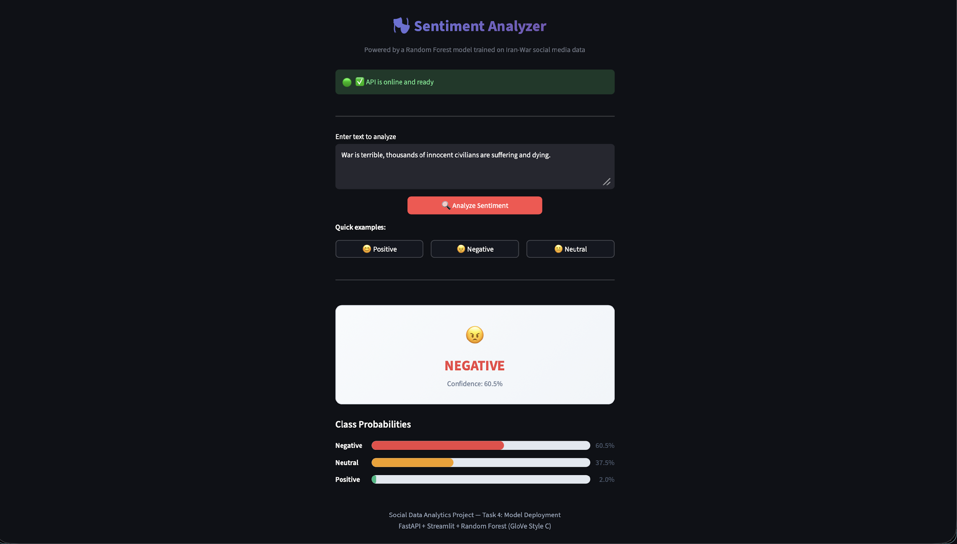
Sentiment Analysis Web Application — Streamlit Frontend

2.9 SOTA Benchmarking (Task 5)
A State-of-the-Art transformer model was selected for comparison:
Field | Value
Model | cardiffnlp/twitter-roberta-base-sentiment-latest
Architecture | RoBERTa-base (125M parameters)
Training Data | ~124M tweets (Jan 2018 – Dec 2021)
Fine-tuning | TweetEval benchmark (sentiment subset)
Revision | 3216a57f2a0d9c45a2e6c20157c20c49fb4bf9c7
Output Classes | 3: negative (0), neutral (1), positive (2)
Preprocessing for SOTA: Minimal cleaning was applied — emoji conversion, URL removal, HTML tag removal, Mastodon artifact removal, and whitespace normalization. Crucially, no lowercasing was performed, as RoBERTa is case-aware. Hashtags and mentions were preserved since the model was fine-tuned on Twitter data and handles them natively.
Label mapping: The model's output labels (negative, neutral, positive) map directly to our ground truth scheme — no transformation required.
SOTA inference was run on both the 100-row test set (for direct comparison with the optimized RF) and the full 500-row labeled dataset.

3. Quantitative Results

3.1 SOTA on Full Dataset (500 rows)
Metric | Value
Accuracy | 0.6520
Macro F1 | 0.5140
Negative — Precision / Recall / F1 | 0.55 / 0.83 / 0.66
Neutral — Precision / Recall / F1 | 0.84 / 0.54 / 0.66
Positive — Precision / Recall / F1 | 0.15 / 0.40 / 0.22

3.2 Side-by-Side Comparison (100-Row Test Set)
Metric | Optimized RF (GloVe style_c) | SOTA (RoBERTa)
Accuracy | 0.7500 | 0.6300
Precision (macro) | 0.5017 | 0.5459
Recall (macro) | 0.4825 | 0.7645
F1 (macro) | 0.4854 | 0.5881
Precision (weighted) | 0.7437 | 0.6732
Recall (weighted) | 0.7500 | 0.6300
F1 (weighted) | 0.7378 | 0.6327

3.3 Per-Class Breakdown
Metric | Optimized RF | SOTA RoBERTa
Negative — Precision | 0.7586 | 0.5370
Negative — Recall | 0.5641 | 0.7436
Negative — F1 | 0.6471 | 0.6237
Neutral — Precision | 0.7465 | 0.7674
Neutral — Recall | 0.8833 | 0.5500
Neutral — F1 | 0.8092 | 0.6408
Positive — Precision | 0.0000 | 0.3333
Positive — Recall | 0.0000 | 1.0000
Positive — F1 | 0.0000 | 0.5000
Note: With only 1 positive sample in the 100-row test set. RF’s 0% recall indicates it missed the sample, while SOTA’s 100% recall means it was identified, though 2 false positives reduced precision to 33%.

3.4 Per-Category Breakdown (by Stance Category)
Stance Category | N | Optimized Acc | Optimized F1 | SOTA Acc | SOTA F1
Pro-Iran | 8 | 0.625 | 0.413 | 0.875 | 0.619
Neutral | 78 | 0.769 | 0.491 | 0.628 | 0.636
Anti-Iran | 14 | 0.714 | 0.476 | 0.500 | 0.285

3.5 Comparison Across All Approaches
Approach | Accuracy | F1 (macro)
Lexicon (SentiWordNet) | 0.55–0.60 | ~0.35–0.40
Lexicon (Bing Liu) | 0.41–0.47 | ~0.35–0.40
Baseline ML (DT/NB, Task 3) | 0.59–0.63 | 0.39–0.41
Optimized RF (Task 4) | 0.75 | 0.49
SOTA RoBERTa (Task 5) | 0.63 | 0.59
The progression from lexicon → classical ML → optimized ML → transformer shows clear trade-offs: the optimized RF maximizes accuracy via majority-class precision, while the SOTA transformer maximizes macro-F1 by achieving more balanced recall across all classes.

4. Visual Analysis

4.1 Confusion Matrices
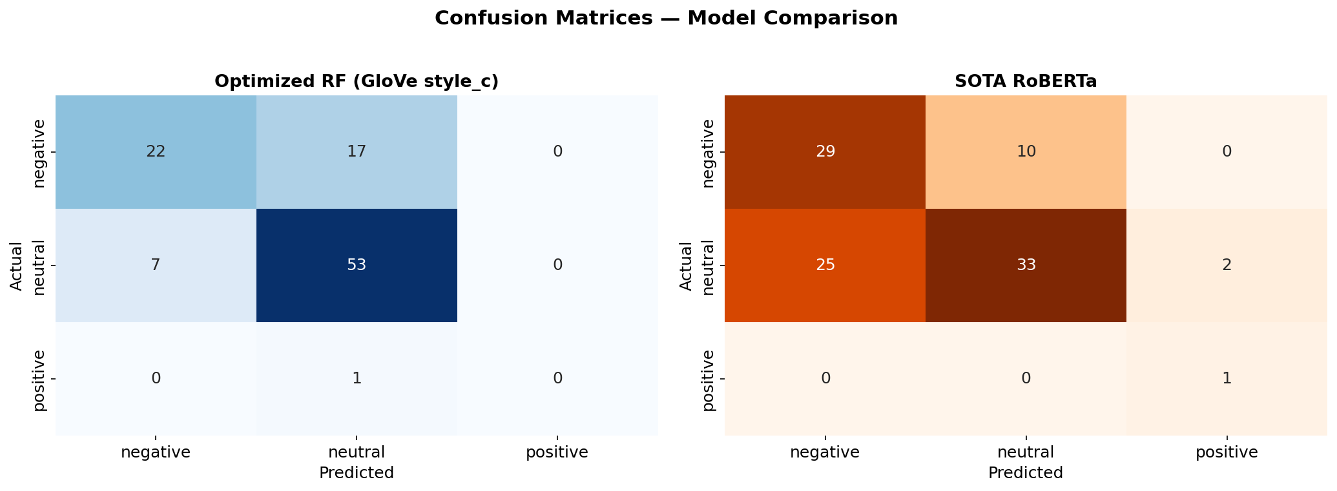
Confusion Matrices — Model Comparison
The confusion matrices reveal complementary error patterns. The RF model (left) shows strong neutral-bias: it correctly classifies 53 out of 60 neutral samples but misclassifies 17 negative samples as neutral. It never predicts positive. The SOTA model (right) shows the opposite: a negative-leaning bias that over-predicts negative (25 neutral samples misclassified as negative), but it successfully identifies the single positive sample.

4.2 Overall Metrics Comparison
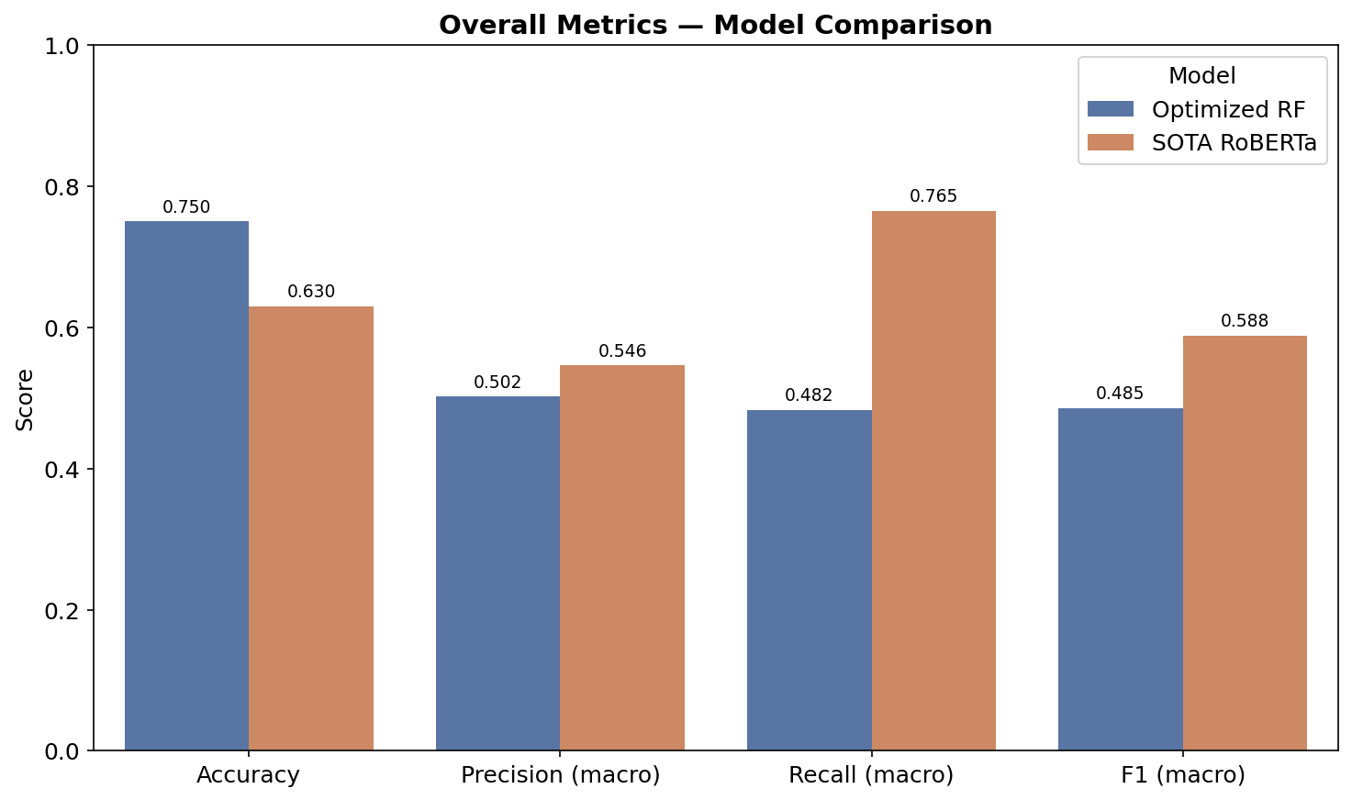
Overall Metrics — Model Comparison
This chart highlights the accuracy vs. macro-F1 trade-off. RF wins on accuracy (0.75 vs 0.63) because accuracy is dominated by the majority class in imbalanced datasets, and RF excels at neutral classification. SOTA wins on macro-F1 (0.59 vs 0.49) because macro-F1 weights all classes equally, and SOTA's ability to detect positive sentiment (F1 = 0.50) gives it a significant edge over RF's zero positive-class performance.

4.3 Per-Class F1 Scores
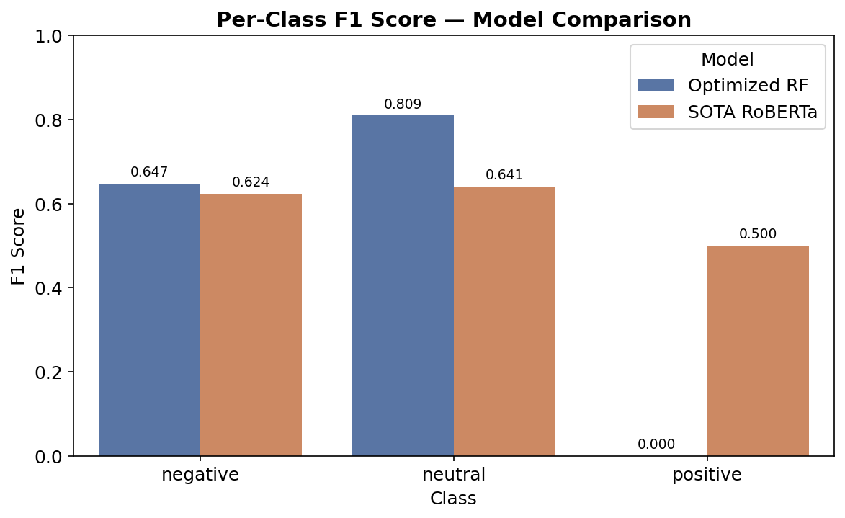
Per-Class F1 Score — Model Comparison
The per-class F1 breakdown reveals where each model excels. Both achieve similar F1 on the negative class (~0.62–0.65). RF significantly outperforms on neutral (0.81 vs 0.64), benefiting from its conservative majority-class strategy. The most striking difference is on the positive class: RF scores 0.000 while SOTA scores 0.500. The transformer's contextual understanding allows it to detect minority-class sentiment that the classical model completely misses.4.4 Per-Category F1 (Macro) by Stance
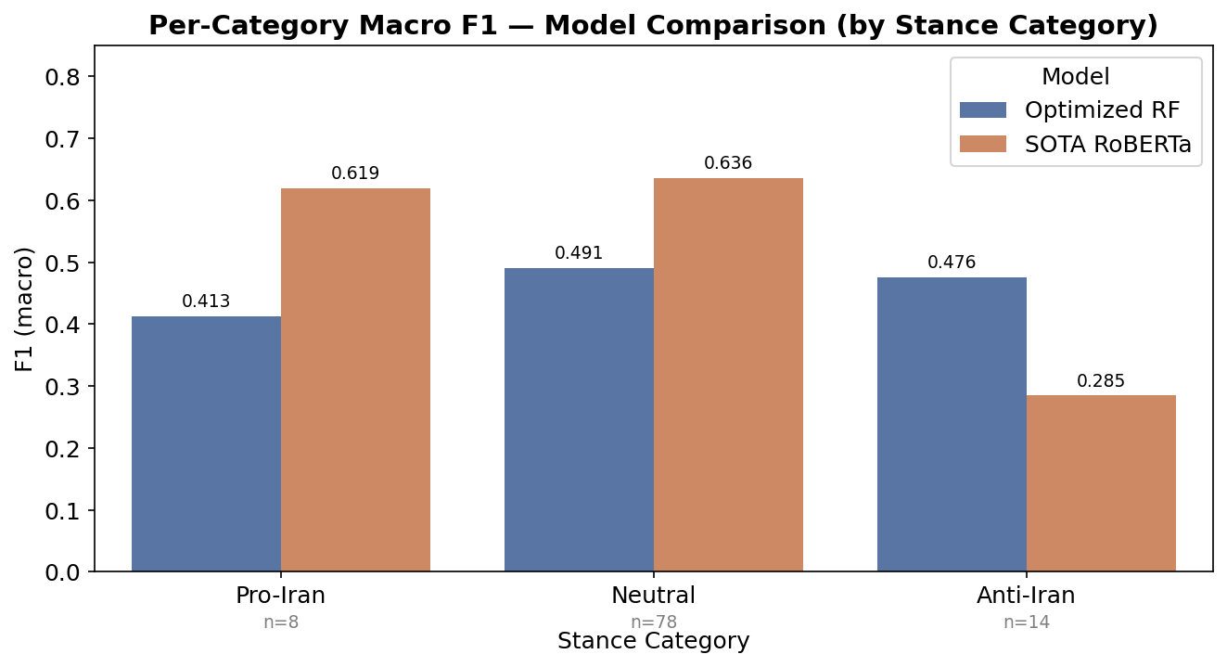
Per-Category Macro F1 — Model Comparison
The stance-category breakdown reveals category-specific strengths. SOTA dominates Pro-Iran posts (0.62 vs 0.41 macro-F1), where nuanced sympathetic language benefits from contextual modeling. SOTA also leads on Neutral-stance posts (0.64 vs 0.49). However, RF wins on Anti-Iran posts (0.48 vs 0.28), where explicitly negative vocabulary ("bomb", "attack", "war") is well-captured by GloVe's direct word-level matching.

4.5 Label Distribution Comparison
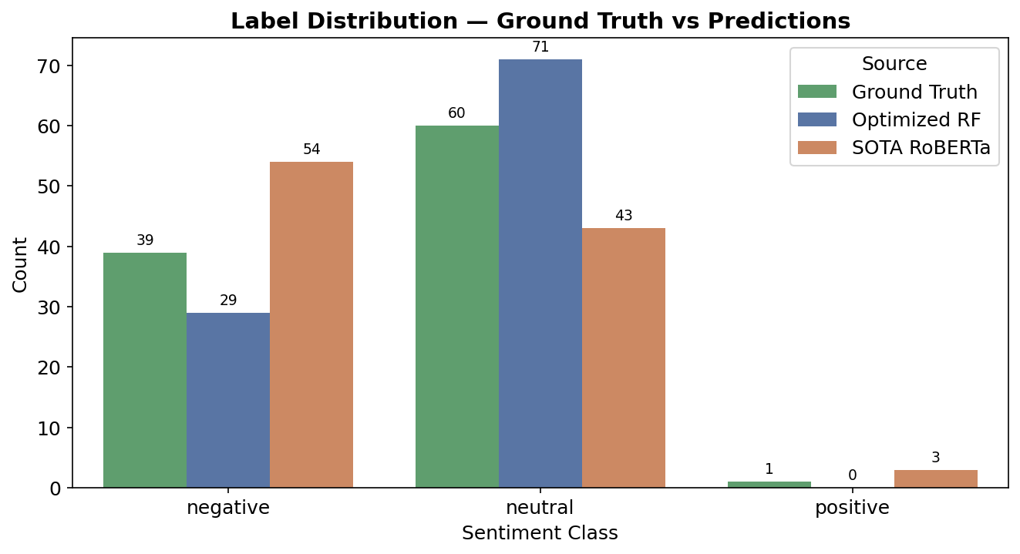
Label Distribution — Ground Truth vs Predictions
This chart exposes each model's class bias. RF over-predicts neutral (+11 vs ground truth) and never predicts positive. SOTA swings in the opposite direction — over-predicting negative (+15) and under-predicting neutral (−17). SOTA does predict positive (3 times) where ground truth has 1, showing sensitivity to positive sentiment at the cost of false positives. These patterns align with each architecture: GloVe averaging tends toward the dominant class, while RoBERTa's fine-tuned attention captures more nuanced signals.

4.6 Confidence Distribution
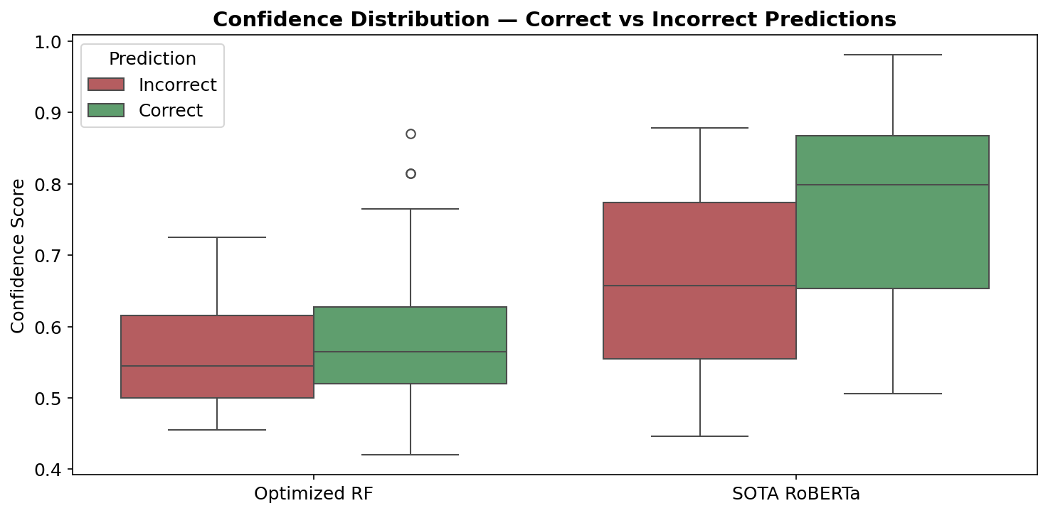
Confidence Distribution — Correct vs Incorrect
The confidence box plots reveal calibration differences. RF confidence is tightly clustered (~0.42–0.87) with little separation between correct and incorrect predictions, suggesting poor calibration. SOTA shows a wider range (~0.45–0.98) and better separation — correct predictions tend to have higher confidence. This has practical implications: SOTA's confidence scores could serve as a meaningful threshold for flagging uncertain predictions in production, whereas RF's confidence provides less actionable signal.

5. Discussion

5.1 Progression of Approaches
- Lexicon-based models (SentiWordNet, Bing Liu): Fast to implement and interpretable, but fundamentally limited. They rely on pre-defined word lists that miss sarcasm, implicit sentiment, domain-specific language, and any form of contextual reasoning. In the Iran War domain, many posts use war vocabulary in factual reporting — lexicons cannot distinguish "Iran was bombed today" (neutral news) from "this bombing is horrific" (negative opinion).
- Feature-engineering + classical ML (Decision Tree, Naive Bayes, Random Forest): A significant step up, with the Random Forest achieving the highest accuracy (0.75). However, the bag-of-embeddings approach still averages away word order and context. Class weighting (positive weight = 50) was necessary to even partially address the 1% positive class, though the test set's single positive sample remained undetected.
- Fine-tuned transformer (SOTA RoBERTa): The contextual attention mechanism enables understanding of nuanced language, sarcasm, and implicit sentiment. Despite lower raw accuracy, the transformer achieves the best macro-F1 (0.59) and is the only model to detect any positive sentiment. Its main weakness is domain mismatch — trained on general Twitter sentiment, it over-predicts negative in war-related factual reporting.

5.2 The Iran War Sentiment Landscape
- 60% neutral: Factual news sharing, links to articles, reposting of journalist reports. Mastodon's user base tends toward information-sharing rather than emotional expression.
- 39% negative: Criticism of military action, expressions of horror at civilian casualties, opposition to government policy. Anti-war sentiment is strongly represented.
- 1% positive: Exceedingly rare — limited to expressions of solidarity or hope for resolution. This reflects the reality that armed conflict generates almost no genuine positive sentiment.
Common patterns include: (1) sarcastic political commentary that reads as positive on the surface but conveys deeply negative sentiment, (2) factual war reporting that describes horrific events in a neutral journalistic register, and (3) highly polarized language around specific actors (Trump, Netanyahu, Iran's leadership) that creates classification ambiguity.

5.3 Why the SOTA Model Underperforms
The SOTA RoBERTa model achieves only 63% accuracy and 0.588 f1 macro despite being a 125M-parameter transformer. This is explained by:
- Domain mismatch: The model was fine-tuned on the TweetEval benchmark (general Twitter sentiment), not on conflict/political discourse. War vocabulary triggers negative predictions even in factual, editorially neutral contexts.
- Ground truth construction: Our labels were generated by LLMs given specific context about the Iran War dataset, enabling them to distinguish factual reporting (neutral) from opinion. RoBERTa applies a generic sentiment lens without this domain context. Additionally, the LLMs used for annotation did not reach complete consensus, yielding a Fleiss' Kappa score of 0.4759. This moderate level of agreement introduces inherent noise into the ground truth, which likely influenced the final evaluation results.

6. Conclusion

6.1 Key Findings
- No single model dominates: The optimized RF achieves higher accuracy (0.75) while the SOTA transformer achieves higher macro-F1 (0.59). The choice depends on whether majority-class precision or balanced class coverage is prioritized.
- Positive sentiment is virtually undetectable by classical ML approaches in this domain. Only the transformer model shows any ability to identify positive sentiment, and even then with limited precision.
- Domain matters more than model size: A 125M-parameter transformer trained on general tweets underperforms a 100-tree Random Forest on this specific conflict-discourse dataset, highlighting the importance of domain-specific training data.
- The sentiment landscape is overwhelmingly negative-to-neutral, consistent with public discourse around armed conflict.

6.2 Limitations
- Small labeled dataset: Only 500 records were labeled, yielding a 100-row test set. Statistical conclusions are constrained by this sample size.
- Extreme class imbalance: With only 1 positive sample in the test set, positive-class metrics have very high variance.
- Single-platform data: Mastodon's user base skews toward tech-savvy, politically engaged users. Sentiment patterns may differ on other platforms (Twitter/X, Reddit, Facebook).
- LLM-generated ground truth: While the majority-vote approach with three LLMs provides reasonable labels, it may encode systematic biases shared by the LLMs.

6.3 Future Work
- Larger labeled dataset: Increasing the labeled set to 2,000+ records would improve statistical reliability and better represent minority classes.
- Domain-specific fine-tuning: Fine-tuning RoBERTa on conflict/political discourse data would likely combine the transformer's contextual strengths with domain-appropriate decision boundaries.
- Multi-platform scraping: Collecting data from multiple social media platforms would provide a more representative picture of public sentiment.
- Temporal analysis: Tracking sentiment trends over time could reveal how public opinion shifts in response to specific war events.

